LUCILIA

LUCILIA

Lucilia

OLIVIA

OLIVIA

Olivia

MIA

MIA

Mia

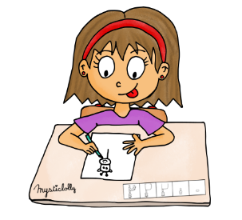



ZORHA

ZORHA

Zorha

MARIUS

MARIUS R.

Marius R.

AXEL

AXEL

Axel

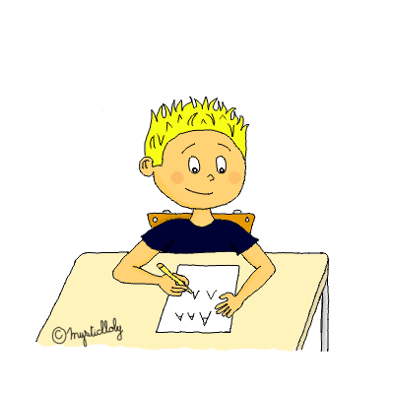



MARIUS

MARIUS B.

Marius B.

Marius

HANNA

HANNA

Hanna

Hanna

LILIAN

LILIAN

Lilian

Lilian







LOUNA

LOUNA

Louna

Louna

MATHILDE

MATHILDE

Mathilde

Mathilde

AGATHE

AGATHE

Agathe

Agathe





EUGENIE

EUGENIE

Eugénie

Eugénie

CAPUCINE

CAPUCINE

Capucine

Capucine

KEWANEE

KEWANEE

Kewanee

Kewanee



TRISTAN

TRISTAN

Tristan

Tristan

CHARLY

CHARLY

Charly

Charly

LOUIS

LOUIS

Louis

Louis







WILLIAM

WILLIAM

William

William



MAEL

MAEL

Maël

Maël

